**CS6680 ADVANCED SOFTWARE ENGINEERING**

**PROJECT 2**

**AUTOMATED TESTING TOOL**

**CONTENTS**

1. Introduction 1
2. Test plan 1
   1. Reasons 1
   2. Features to be tested 2
3. Test Design Specification 3
4. Test Procedure Specification 3
5. Test Case Specification 3
   1. Test Cases 4
   2. Test Scripts 4
6. TestComplete Testing Tool 5
   1. Installation guide 5
   2. Download 6
7. Creating new Test Project 7
8. Testing Cases 9
   1. Creating Tests in TestComplete 9
   2. Recording Tests in TestComplete 9
9. Test log and Execution Summary 10
10. Test Case Summary 15
11. Conclusion 16
12. **Introduction:**

Software Testing is an integral part of software quality and it is the most important activity for supporting entire Software Development Life Cycle (SDLC). Software Testing not just plays a significant role in SDLC for meeting the standards of an application but it also reflects in building up the reputation of an organization. In every development firm, Quality Assurance (QA) plays a crucial role in the various stages of SDLC. QA is performed to evaluate the quality-related aspects of an application and to verify its behavior in different configurations of the systems.

1. **Test plan**

* Test Plan Ensures all Functional and Design Requirements are implemented as specified in the documentation.
* To provide a procedure for Unit and System Testing.
* To identify the documentation process for Unit and System Testing.
* To identify the test methods for Unit and System Testing.

**2.1 Reasons:**

* We create a test plan because preparing it helps us to think through the efforts needed to validate the acceptability of a software product.
* We create a test plan because it can and will help people outside the test group to understand the why and how of product validation.
* We create a test plan because, in regulated environments, we have to have a written test plan.
* We create a test plan because the general testing process includes the creation of a test plan.
* We create a test plan because we want a document that describes the objectives, scope, approach and focus of the software testing effort.
* We create a test plan because it includes test cases, conditions, the test environment, a list of related tasks, pass/fail criteria, and risk assessment.
* We create test plan because one of the outputs for creating a test strategy is an approved and signed off test plan document.
* We create a test plan because the software testing methodology a three step process, and one of the steps is the creation of a test plan.
* We create a test plan because we want an opportunity to review the test plan with the project team.
* We create a test plan document because test plans should be documented, so that they are repeatable.

In software testing, a test plan gives detailed testing information regarding an upcoming testing effort, including

* Scope of testing
* Schedule
* Test Deliverables
* Release Criteria
* Risks and Contingencies

**2.2 Features to be tested**

The set of test objectives covered by this test design specification. It is the overall purpose of this document to group related test items together.

* Features
* Attributes and Characteristics
* Usability

1. **Test Design Specification**

**Outline**

A test-design specification document shall have the following structure.

1. Test-design-specification identifier  
2. Features to be tested  
3. Approach refinements  
4. Test identification  
5. Feature pass/fail criteria  
6. Special Requirements  
7. Procedure Steps

1. **Test procedure specification**

Test processes determine whether the development products of a given activity conform to the requirements of that activity and whether the system and/or software satisfies its intended use and user needs. The scope of testing encompasses software-based systems, computer software, hardware, and their interfaces.

1. **Test Case Specification**

The Test Case Specification is developed in the Development Phase by the organization responsible for the formal testing of the application. A Test Case Specification describes the purpose of a specific test, identifies the required inputs and expected results, provides step-by-step procedures for executing the test, and outlines the pass/fail criteria for determining acceptance.

**5.1 Test Cases**

Test cases are a set of conditions or variables under which a tester will determine if a requirement upon an application is partially or fully satisfied.

There must be at least one test case for each requirement for traceability.

Each test case will have a known input and an expected output, worked out before the test.

**5.2 Test Scripts**

Test Scripts are a set of instructions that will be performed on the System to test that the system functions as expected. These steps can be executed manually or automatically. Can either be written using a special automated functional GUI test tool or in a well-known programming language. Automated test tools can test many areas of system functionality such as the user interface, performance of the system, the system code and the requirements.

Automated testing has the advantage over manual testing in that it is easily repeatable, and thus is favored when doing regression testing. The test plan focuses on how the testing for the project will proceed, which units will be tested and what approaches (and tools) are to be used during the various stages of testing. However, it does not deal with details of testing a unit nor does it specify which test cases are to be used.

Test case specification has to be done separately for each unit. Based on the approach specified in the test plan first the feature to be tested for this unit must be determined. The overall approach stated in the plan is refined into specific test techniques that should be followed and into the criteria to be used for evaluation. Based on these the test cases are specified for testing unit. The two basic reasons test cases are specified before they are used for testing. It is known that testing has severe limitations and the effectiveness of testing depends very heavily on the exact nature of the test case. Even for a given criterion the exact nature of the test cases affects the effectiveness of testing.

Constructing good test case that will reveal errors in programs is still a very creative activity that depends a great deal on the tester. Clearly it is important to ensure that the set of test cases used is of high quality. As with many other verification methods evaluation of quality of test case is done through "test case review" And for any review a formal document or work product is needed. This is the primary reason for having the test case specification in the form of a document.

1. **TestComplete Testing Tool:**

We are using Testcomplete testing tool in this project for testing. TestComplete is an automated testing environment for a wide range of application types and technologies, including (but not limited to) Windows, .NET, WPF, Visual C++, Visual Basic, Delphi, C++Builder, Java and Web applications and services.

TestComplete is oriented equally to functional and unit testing. It provides superior support for daily regression testing and supports many other kinds of testing: data-driven testing, distributed testing, and others.

You create tests by recording them or editing test commands in TestComplete’s panels and editors. Tests can be run from within TestComplete or they can be exported to an external application and run there. TestComplete recognizes objects and controls in tested applications and offers special commands for simulating user actions with them. It also offers specific checkpoints that let you easily verify the application state during the test run.

If the built-in means are insufficient for simulating user actions on the tested application or checking the application state, you can take advantage of accessing the application’s internal objects, methods and properties to perform the needed tasks.

**6.1 Testing tool Installation Guide:**

#### Recommended System Requirements

* A 64-bit operating system like Windows 7 or later.
* Microsoft Internet Explorer 9.0 or later.
* Intel Core i5 or Intel Core i7 (the 3rd generation).
* 6 GB of RAM or more.
* 1 GB of free disk space for installation, plus extra space for temporary files during test runs
* 1280×1024 or higher resolution monitor.
* Mouse or other pointing device.

**6.2 Download:**

The download of the TestComplete trial package starts right after you submit a request for the trial version on the SmartBear website: <http://smartbear.com/product/testcomplete/free-trial/>

To install TestComplete:

* Double-click the TestComplete installation package. The installation wizard will start and display the license agreement.
* Read the license agreement. If you accept the license conditions, select **I accept the terms of the license agreement** and click **Next**. Else, click **Cancel** to exit the installation wizard.
* On the next page, select the folder to install TestComplete to:

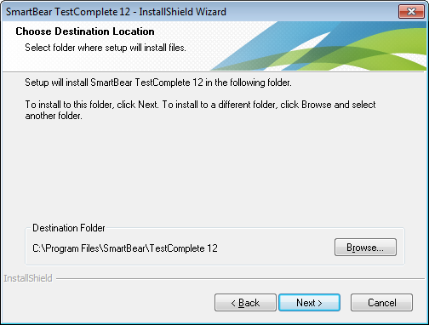

* Click **Install** to start the installation.

1. **Creating a new test project:**
2. Select **File | New | New Project** from TestComplete’s main menu. This will call up the [Create New Project](https://support.smartbear.com/viewarticle/81169/) wizard:

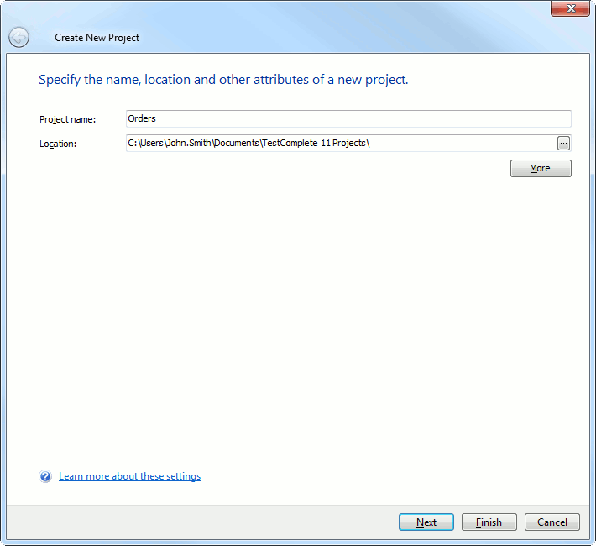

1. On the first page of the wizard, you can specify the project name and location. Enter *name of the project* into the **Project name** edit box. TestComplete will automatically generate the project path and display it in the **Location** field. The project folder is used to store all information generated for or by the project: keyword tests, scripts, test logs, stores, and so on. You can change the project’s folder in the Location box. In our example we will keep the folder name unchanged.

You can also specify the project suite name and its actual location by clicking the **More** button and filling in the corresponding edit fields. In our example, we will keep the project suite name and location unchanged.

1. After you specify the project name and location, click **Next** to continue
2. After you specify the project name and location on the first page of the wizard, the wizard shows the second page where you can choose the type of your tested application:

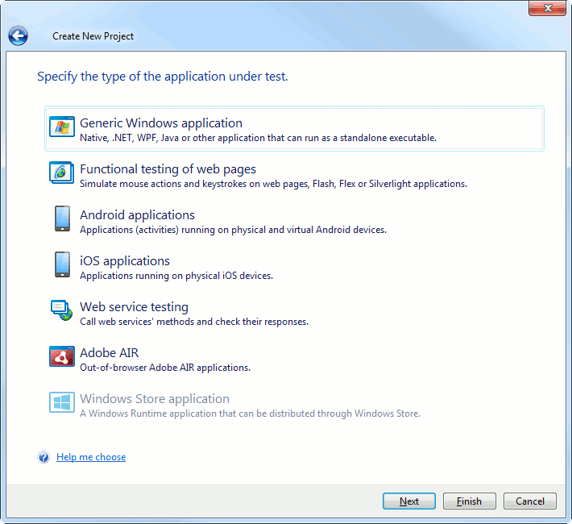

This will help TestComplete choose the appropriate run mode for your application.

1. On the next page of the wizard, you can add the tested application to your test project:

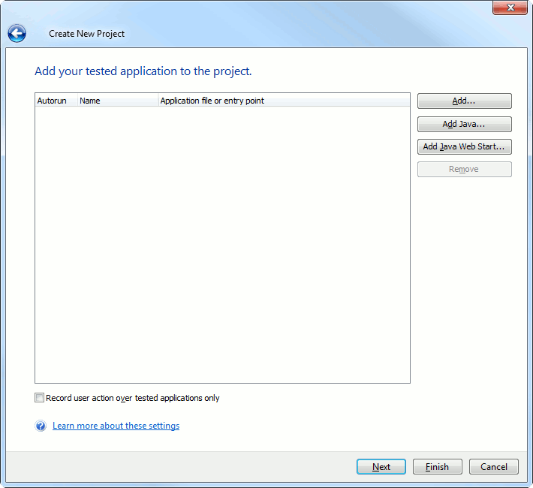

1. **Testing Cases:**

* **Test purpose:** The test should check whether the Edit project form saves the modified data and the changes are visible in the order list.
* **Testing steps:** Our test should simulate modifying the project’s details and then verify the data in the project list. We will record a test simulating user actions over the application. For simplicity, our test will “change” only one property at a time.
* **Checking and logging the test result:** If the change made to the project has been saved correctly, it should be visible in the project list. To check this, our test will compare the data in the list with an expected value. We will add a special comparison command to the test for this. This command will post the comparison results to the test log, so we will see whether the verification failed or passed successfully.

#### 8.1 Creating Tests in TestComplete

TestComplete allows you to create tests in two ways. You can:

* Create tests manually
* Record tests

When you create a test manually, you enter all the needed commands and actions that your test must perform via appropriate script objects or keyword test commands. This approach is very helpful when you need to create very powerful and flexible tests or if you have good experience in creating tests.

However, creating tests manually requires a lot of time and does not prevent you from different problems.

#### 8.2 Recording Tests in TestComplete

The recording includes three steps:

1. You start recording by selecting **Test | Record | Record Keyword Test** or **Test | Record | Record Script** from TestComplete’s main menu or from the Test Engine toolbar. You can also start recording by clicking **Record a New Test** on the Start Page.

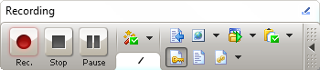

1. After starting the recording, perform the desired test actions: launch the tested application (if needed), work with it by clicking command buttons, selecting menu items, typing text and so on.
2. After all the test actions are over, stop the recording by selecting https://support.smartbear.com/images/support/kb/data/2014/3/11/Stop_b.gif **Stop** from the Recording toolbar.
3. **Test Log & Execution Summary:**

|  |  |  |  |  |  |
| --- | --- | --- | --- | --- | --- |
| Test Case ID | Description | precondition | input | Expected result | Status |
| 01 | open file | On click file open | Click on file | File opened | pass |
| 02 | Save file | On click save file | Click on save button | File saved | pass |
| 03 | Name to save file | File name start with alphabets | integer | Didn’t named | fail |
| 04 | Zoom in | On click zoom in | Click on zoom button | Zoom in successful | pass |
| 05 | Zoom out | On click zoom out | Click on zoom button | Zoom out successful | pass |
| 06 | Draw a rectangle | On click rectangle should draw | Click on rectangle shape | Rectangle draw done | pass |
| 07 | Draw a circle | On click circle draw | Click on circle shape | circle draw done | pass |
| 08 | Save as file | On click save as file | Click on save as button | File saved | pass |
| 09 | Print paint file | On click print | Click on print | Print done | pass |
| 10 | Image property show | On clicked image property | Click on image property | Showed image property | pass |
| 11 | Eraser to erase | On clicked eraser | Click on eraser to remove | Successfully removed | pass |
| 12 | Color pick by picker | On clicked color picker | Click on color picker | Color piker successfully clicked | pass |
| 13 | Choose color | On choose color | Click on choose color | Successfully chosen one | pass |
| 14 | Draw a right triangle | On click right triangle draw | Click on right triangle shape | right triangle draw done | pass |
| 15 | Draw a line | On click line draw | Click on line | line done | pass |
| 16 | Draw an oval | On click oval draw | Click on oval shape | oval draw done | pass |
| 17 | Draw a Polygon | On click Polygon draw | Click on Polygon shape | Polygon draw done | pass |
| 18 | Draw a rounded rectangle | On click rounded rectangle should draw | Click on rounded rectangle shape | rounded Rectangle draw done | pass |
| 19 | Draw a cube | On click cube draw | Click on cube shape | cube draw done | pass |
| 20 | Draw a diamond | On click diamond draw | Click on diamond shape | diamond draw done | pass |
| 21 | Draw a triangle | On click triangle draw | Click on triangle shape | triangle draw done | pass |
| 22 | Draw a pentagon | On click pentagon draw | Click on pentagon shape | pentagon draw done | pass |
| 23 | Draw a hexagon | On click hexagon draw | Click on hexagon shape | hexagon draw done | pass |
| 24 | Draw a right arrow | On click right arrow draw | Click on right arrow shape | right arrow draw done | pass |
| 25 | Draw a left arrow | On click left arrow draw | Click on left arrow shape | left arrow draw done | pass |
| 26 | Draw an up arrow | On click up arrow draw | Click on up arrow shape | up arrow draw done | pass |
| 27 | Draw a down arrow | On click down arrow draw | Click on down arrow shape | down arrow draw done | pass |
| 28 | Draw a gray triangle | On click gray triangle draw | Click on gray triangle shape | gray triangle draw done | pass |
| 29 | Draw a | On click triangle draw | Click on triangle shape | triangle draw done | pass |
| 30 | Draw a green triangle | On click green triangle draw | Click on green triangle shape | green triangle draw done | pass |
| 31 | Draw a red triangle | On click red triangle draw | Click on red triangle shape | red triangle draw done | pass |
| 32 | Draw a can | On click can draw | Click on can shape | can draw done | pass |
| 33 | Draw a lighting | On click lighting draw | Click on lighting shape | lighting draw done | pass |
| 34 | Draw a parallelogram | On click parallelogram draw | Click on parallelogram shape | Parallelogram draw done | pass |
| 35 | Draw a heart | On click heart draw | Click on heart shape | heart draw done | pass |
| 36 | Draw a cloud call-out | On click cloud call-out draw | Click on cloud call-out shape | cloud call-out draw done | pass |
| 37 | Draw an oval call-out | On click oval call-out draw | Click on oval call-out shape | oval call-out draw done | pass |
| 38 | Draw a call-out | On click call-out draw | Click on call-out shape | call-out draw done | pass |
| 39 | Draw a six-point star | On click six-point star draw | Click on six-point star shape | six-point star draw done | pass |
| 40 | Draw a five-point star | On click five-point star draw | Click on five-point star shape | five-point star draw done | pass |
| 41 | Draw a four-point star | On click four-point star draw | Click on four-point star shape | four-point star draw done | pass |
| 42 | Draw a green four-point star | On click green four-point star draw | Click on green four-point star shape | green four-point star draw done | pass |
| 43 | Select black color | On clicked black color | Click on black color | Successfully selected | pass |
| 44 | Select gray-50% color | On clicked gray-50% color | Click on gray-50% color | Successfully selected | pass |
| 45 | Select gray-25% color | On clicked gray-25% color | Click on gray-25% color | Successfully selected | pass |
| 46 | Select white color | On clicked white color | Click on white color | Successfully selected | pass |
| 47 | Select dark red color | On clicked dark red color | Click on dark red color | Successfully selected | pass |
| 48 | Select brown color | On clicked brown color | Click on brown color | Successfully selected | pass |
| 49 | Select gold color | On clicked gold color | Click on gold color | Successfully selected | pass |
| 50 | Select dark brown color | On clicked dark brown color | Click on dark brown color | Successfully selected | pass |
| 51 | Select light black color | On clicked light black color | Click on black light color | Successfully selected | pass |
| 52 | Select pink color | On clicked pink color | Click on pink color | Successfully selected | pass |
| 53 | Select indigo color | On clicked indigo color | Click on indigo color | Successfully selected | pass |
| 54 | Select blue color | On clicked blue color | Click on blue color | Successfully selected | pass |
| 55 | Select lime color | On clicked lime color | Click on lime color | Successfully selected | pass |
| 56 | Select yellow color | On clicked yellow color | Click on yellow color | Successfully selected | pass |
| 57 | Select dark green color | On clicked dark green color | Click on dark green color | Successfully selected | pass |
| 58 | Select green light color | On clicked green light color | Click on green light color | Successfully selected | pass |
| 59 | Select green color | On clicked green color | Click on green color | Successfully selected | pass |
| 60 | Select black color | On clicked black color | Click on black color | Successfully selected | pass |
| 61 | Select dark yellow color | On clicked dark yellow color | Click on dark yellow color | Successfully selected | pass |
| 62 | Select light yellow color | On clicked light yellow color | Click on light yellow color | Successfully selected | pass |
| 63 | Select orange color | On clicked orange color | Click on orange color | Successfully selected | pass |
| 64 | Select rose color | On clicked rose color | Click on rose color | Successfully selected | pass |
| 65 | Select red color | On clicked red color | Click on red color | Successfully selected | pass |
| 66 | Select dark blue color | On clicked dark blue color | Click on dark blue color | Successfully selected | pass |
| 67 | rotate | On clicked rotate | Click on rotate | Successful rotate | pass |
| 68 | Right rotate | On clicked rotate | Click on rotate | Successful rotate | pass |
| 69 | left rotate | On clicked left rotate | Click on left rotate | Successful rotate | pass |
| 70 | resize | On click resize | Click on resize | Successfully | pass |
| 71 | cut | On click cut | Click on cut | successfully | pass |
| 72 | Copy | On click copy | Click on copy | successfully | pass |
| 73 | paste | On click paste | Click on paste | successfully | pass |
| 74 | undo | On click undo | Click on undo | successfully | pass |
| 75 | Select pencil | Click on select pencil | Click on pencil | Successfully  undo | pass |
| 76 | Select brush | On click brush select | Click on brush | successfully | pass |
| 77 | Select edit colors | On click brush select | Click on brush | successfully | pass |
| 78 | Shape fill with color | On click selected color | Click on fill shape color | successful | pass |
| 79 | magnifier | On click magnifier | Click on magnifier | successful | pass |
| 80 | Text write | On click text | Click on text | Successful wrote | pass |
| 81 | crop | On click crop | Click on crop | successfully | pass |
| 82 | Select size | On click size | Click on size to choose | successful | pass |
| 83 | Select color two | On click color two | Color two click | successful | pass |
| 84 | full screen | On click full screen | Click on full screen | successful | pass |
| 85 | View status bar | On click view | Click on view | successful | pass |
| 86 | Send an email | On click email | Email entered | successful | pass |
| 87 | Set as background | On click set as background | Click on set background | successful | pass |
| 88 | redo | On click redo | Click on redo | successful | pass |
| 89 | About paint | On click about paint | Click on about | successful | pass |
| 90 | Select font | On click font | Click on font | successful | pass |
| 91 | Select all | On click select all | Click on select all | successful | pass |
| 92 | Free form selection | On click | Click on free form | successful | pass |
| 93 | Shape outline | On click outline | Click on shape outline | successful | pass |
| 94 | Open new | On click new | Click on new | successful | pass |
| 95 | Fill with color | On click fill with color | Click on fill with color | successful | pass |
| 96 | Select gold color | On click gold color | Click on gold color | successful | pass |
| 97 | Print view | On click print view | Click on print view | successful | pass |
| 98 | Show below the ribbon | On click show below ribbon | click on show below ribbon | successful | pass |
| 99 | Minimize the ribbon | On click Minimize the ribbon | Click on Minimize the ribbon | successful | pass |
| 100 | Exit | On click Exit | Click on exit | Successful exit | pass |

1. **Test Case Summary:**

Test summary report gives the status of Testing by us, it is nothing but daily report regarding testing. It consists of different columns based on the company. Some of the columns are:

|  |  |
| --- | --- |
| Project Application | Windows Paint |
| Completed by | Ridhima B |
| Completed Date | 11/13/2016 |
| Total Test Cases | 100 |
| Executed Test Cases | 100 |
| Success Cases | 99 |
| Failed Cases | 1 |
| Test Coverage | 100 |
| % of Complete | 100% |
| Pass Percentage | 99% |
| Fail Percentage | 1% |

1. **Conclusion**

Test planning is an essential phase of the SDLC providing detailed information about how to approach and conclude the testing of software. Testing is one of the most important phases of the SDLC, accounting for a large portion of the software’s budget. Without a detailed test plan, an end product can be bug ridden and in turn unsuccessful. Detailed test planning will ensure problems are dealt with if they arise, be it software problems or test problems. With levels of test plan providing different levels of information, developers can ensure successful testing of a product. Such a systematic approach as specified by the IEEE 829-1998 Test Plan Structure, provides developers with software specific categories to guarantee a successful software testing stage.